**Marketing Mix – 4 P’s**

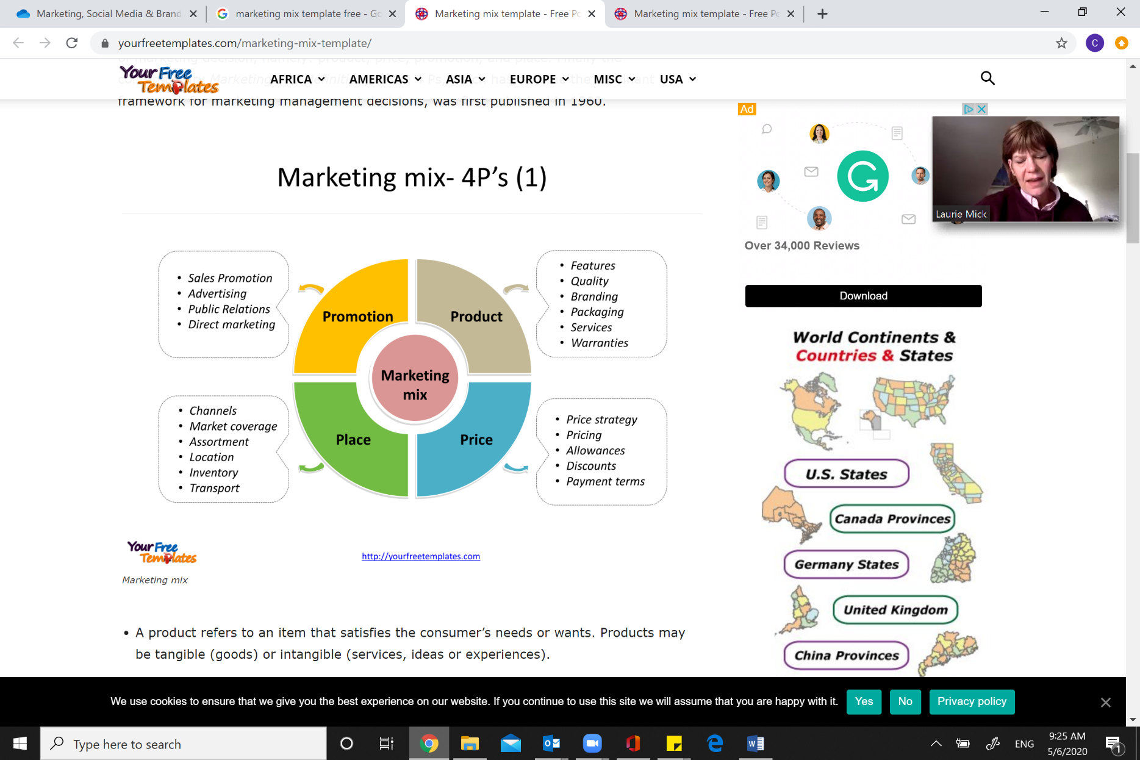

**Marketing Mix – 7P's**

